**Ex: No: STOCK MAINTENANCE SYSTEM**

**Date:**

**AIM:**

ToDesign, Implement and Test the Stock Maintenance System described in the given problem statement .

**PROBLEM STATEMENT:**

Stock Maintenance System is a real time application used in the merchants day to day system. This is a database to store the transaction that takes places between the manufacturer,dealer and the shop keeper that includes stock inward and stock outward with reference to the dealer.

Here we assume ourself as the dealer and proceed with the transaction as follows

* The manufacturer is the producer of the items and it contains the necessary information of the item such as price per item, Date of Manufacture, Best Before Use, Number of item available and their company address.
* The dealer is the secondary source of an item and he purchases item from the manufacture by requesting the required item with its corresponding company name and the number of items required.
* The dealer is only responsible for distribution of the itemn to the retailers in the town of city.
* The shop keeper or retailer is the one who is prime source for selling items in the market.
* The customers get item from the shopkeeper and not directly from the manufacture or the dealer.
* The stock is the database used in our system which records all transactions that takes place between the manufacture and the dealer and the dealer and the retailer.

The process of stock maintenance system is that the customer login to the particular site to place that the order for the customer product. The stock maintenance system are described sequentially through steps.

1. The customer login to the particular site
2. They fill the customer details
3. They place the orders for their product.
4. The vendor login and views the customer details and order

**USECASE DIAGRAM:**



**CLASS DIAGRAM:**

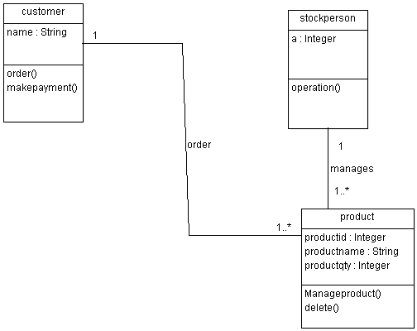

**SEQUENCE DIAGRAM:**

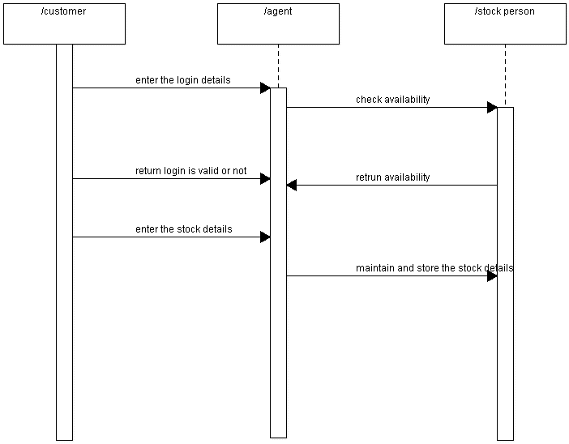

**COLLABORATION DIAGRAM:**

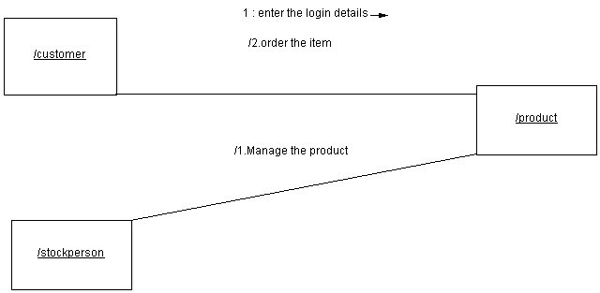

**ACTIVITY DIAGRAM:**

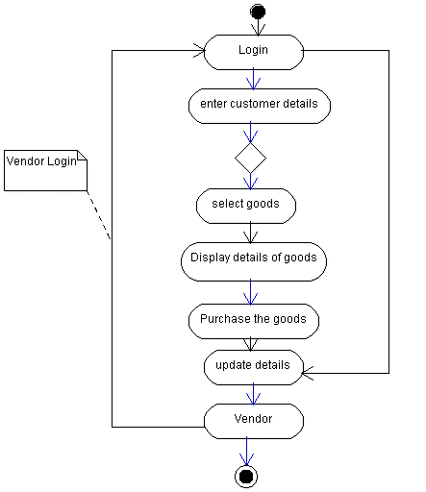

**STATE CHART DIAGRAM:**

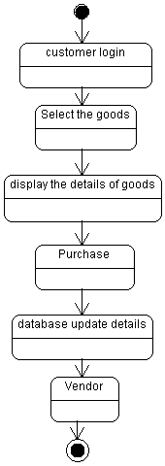

**COMPONENT DIAGRAM:**

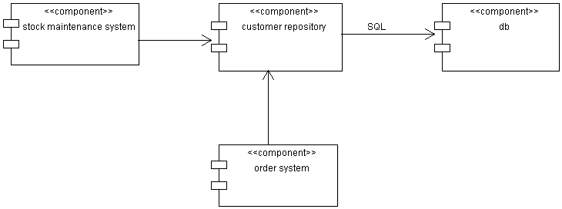

**DEPLOYMENT DIAGRAM:**

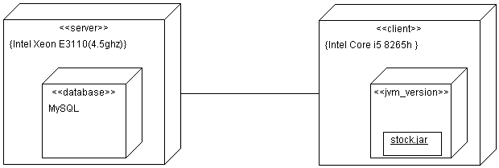

**IMPLEMENTATION & TESTING**

**Product.java:**

package product;

importjava.util.*;

import java.io.*;

class Product extends Customer

{

intt;intf;inti=0;int count=0,count1=0;

public static int[] pid=new int[100];

public static String[] pname=new String[100];

public static int[] qty=new int[100];

public static int[] ord=new int[100];

public void manageproduct()

{

Scanner s=new Scanner(System.in);

do

{

System.out.println("1.Add\n 2.display\n 3.delete\n 4.update\n");

System.out.println("enter the option");

int n=s.nextInt();

switch(n)

{

case 1:

System.out.println("enter the number of items to be added");

int no=s.nextInt();

System.out.println("enter the id,name,qty of the product to be added");

no=no-1;

int f=i+no;

for(;i<=f;i++)

{

pid[i]=s.nextInt();

pname[i]=s.next();

qty[i]=s.nextInt();

}

i=i;

System.out.println("items added successfully");

break;

case 2:

System.out.println("enter the number of items to be printed");

int scan=s.nextInt();

for(inti=0;i<scan;i++)

{

System.out.println("pidpnameqty ");

System.out.println(pid[i]+"\t"+pname[i]+"\t"+qty[i]);

}

System.out.println("the product information is displayed");

break;

case 3:

System.out.println("enter the id of the product to be deleted");

int did=s.nextInt();

for(inti=0;i<=pid.length-1;i++)

{

if(pid[i]!=0)

{

count++;

}

}

for(i=0;i<=count+1;i++)

{

if(pid[i]==did)

{

pid[i]=pid[count-1];

pname[i]=pname[count-1];

qty[i]=qty[count-1];

pid[count-1]=pid[pid.length-1];

pname[count-1]=pname[pname.length-1];

qty[count-1]=qty[qty.length-1];

break;

}

}

System.out.println("product is successfully deleted");

break;

case 4:

System.out.println("enter the id,name,qty of the product to be added");

intnid=s.nextInt();

String nname=s.next();

intnqty=s.nextInt();

for(inti=0;i<=pid.length;i++)

{

if(pid[i]==nid)

{

pid[i]=nid;

pname[i]=nname;

qty[i]=nqty;

break;

}

}

System.out.println("product is updated successfully");

break;

case 5:

System.exit(0);

}

System.out.println("enter 1 to continue to manage product");

t=s.nextInt();

}while(t==1);

}

public static void main(String args[])

{

Stockperson sp=new Stockperson();

sp.operation();

}

public void delete(int n)

{

int did=n;

for(inti=0;i<=pid.length-1;i++)

{

if(i!=0)

{

count1++;

}

}

for(inti=0;i<=count1;i++)

{

if(pid[i]==did)

{

qty[i]=qty[count1];

break;

}

}

}

}

**Stockperson.java**

package product;

importjava.util.Scanner;

import java.io.*;

class Stockperson extends Product

{

public void operation()

{

int a;

do

{

System.out.println("select an option");

System.out.println("1.stockperson login\t2.Customer login\t3.exit");

Scanner s=new Scanner(System.in);

int m=s.nextInt();

switch(m)

{

case 1:

{

Product p=new Product();

p.manageproduct();

break;

}

case 2:

{

Customer c=new Customer();

c.order();

break;

}

case 3:

System.exit(0);

}

System.out.println("enter 1 to continue to select login");

a=s.nextInt();

}while(a==1);

}

}

**Customer.java**

package product;

importjava.util.*;

import java.io.*;

class Customer

{

public void order()

{

Scanner s=new Scanner(System.in);

Product p=new Product();

System.out.println("enter the product id to be ordered");

int search=s.nextInt();

p.delete(search);

System.out.println("item ordered successfully");

System.out.println("enter 1to make payment");

int b=s.nextInt();

if(b==1)

{

Customer c=new Customer();

c.makepayment();

}

}

public void makepayment()

{

System.out.println("payment successfull");

}

}

**Output:**

select an option

1.stockperson login 2.Customer login 3.exit

1

1.Add

2.display

3.delete

4.update

enter the option

1

enter the number of items to be added

3

enter the id,name,qty of the product to be added

1

tea

3

2

coffee

4

3

boost

5

items added successfully

enter 1 to continue to manage product

2

enter 1 to continue to select login

1

select an option

1.stockperson login 2.Customer login 3.exit

1

1.Add

2.display

3.delete

4.update

enter the option

2

enter the number of items to be printed

3

pidpnameqty

1 tea 3

pidpnameqty

2 coffee 4

pidpnameqty

3 boost 5

the product information is displayed

enter 1 to continue to manage product

1

1.Add

2.display

3.delete

4.update

enter the option

3

enter the id of the product to be deleted

1

product is successfully deleted

enter 1 to continue to manage product

1

1.Add

2.display

3.delete

4.update

enter the option

4

enter the id,name,qty of the product to be added

2

tea

2

product is updated successfully

enter 1 to continue to manage product

1

1.Add

2.display

3.delete

4.update

enter the option

2

enter the number of items to be printed

2

pidpnameqty

3 boost 5

pidpnameqty

2 tea 2

the product information is displayed

enter 1 to continue to manage product

1

1.Add

2.display

3.delete

4.update

enter the option

1

enter the number of items to be added

1

enter the id,name,qty of the product to be added

1

coffee

6

items added successfully

enter 1 to continue to manage product

0

enter 1 to continue to select login

1

select an option

1.stockperson login 2.Customer login 3.exit

2

enter the product id to be ordered

1

item ordered successfully

enter 1to make payment

1

paymentsuccessfull

enter 1 to continue to select login

1

select an option

1.stockperson login 2.Customer login 3.exit

1

1.Add

2.display

3.delete

4.update

enter the option

2

enter the number of items to be printed

2

pidpnameqty

1 coffee 0

pidpnameqty

2 tea 2

the product information is displayed

enter 1 to continue to manage product

1

enter 1 to select login

select an option

1.stockperson login 2.customer login 3.exit

3

Build successful...

**TEST REPORT 1**

**Product : Stock Maintenance System**

**Use Case :manageproduct**

|  |  |  |  |  |
| --- | --- | --- | --- | --- |
| **Test Case ID** | **Test Case / Action To Perform** | **Expected Result** | **Actual Result** | **Pass/Fail** |
| 1. 1 | After Entering the product id,name,qty | Displays ”items added successfully” | Items added successfully | Pass |
|  | After Entering the product Id to be deleted | Displays “product is successfully deleted” | Product is successfully deleted | Pass |

**TEST REPORT 2**

**Product :Stock Maintenance System**

**Use Case : manageproduct**

|  |  |  |  |  |
| --- | --- | --- | --- | --- |
| **Test Case ID** | **Test Case / Action To Perform** | **Expected Result** | **Actual Result** | **Pass/Fail** |
|  | After selecting “add” option | Displays “Enter the number of items to be added” | Enter the number of items to be added.  3 | Pass |
|  | After selecting “update” option | Displays “Enter the id,name,qty” of the product to be updated | Enter the id,name,qty of the product to be updated.  3  Coffe  7 | Pass |

**TEST REPORT 3**

**Product : Stock Maintenance System**

**Use Case :Make Payment**

|  |  |  |  |  |
| --- | --- | --- | --- | --- |
| **Test Case ID** | **Test Case / Action To Perform** | **Expected Result** | **Actual Result** | **Pass/Fail** |
|  | After items ordered successfully | Displays “Enter 1 to make payment” | Enter 1 to make payment | Pass |
|  | After Entering ‘1’ to make payment | Displays “Payment successful” | Payment successful | Pass |